About the Address Book sample
The Address Book sample shows you how to use the SOAPInput, SOAPReply, and SOAPRequest nodes to both provide and consume a Web service through an HTTP or JMS transport.
The starting point for the sample is a WSDL file that defines an address book, see WSDL file. The WSDL file, which contains both HTTP and JMS bindings, points to the operations that are defined in the WSDL. The Web service performs two operations; it stores addresses and finds addresses. If you have access to WebSphere Application Server you can interchange the provider and consumer included with this sample with the provider and consumer provided with the Address Book sample in WebSphere Application Server for SOAP over HTTP. The Address Book sample provided with the WebSphere Application Server does not support SOAP over JMS transport. To support SOAP over JMS transport, you must regenerate the Web Service sample by adding a JMS binding and port to the WSDL to interoperate with the WebSphere Application Server, see the WSDL file provided with this sample.
To create the message set and a blank message flow for the provider, use the "Start from WSDL and/or XSD files" wizard with the WSDL file. You can then create a consumer flow manually.
The Address Book sample demonstrates the following tasks:
- How to provide a Web service by using the SOAPInput and SOAPReply nodes.
- How to consume a Web service by using a SOAPRequest node.

Setting up the Address Book samples to use HTTP
The sample provides both a Web service consumer and a Web service provider. You call the consumer by using WebSphere MQ, but you see only the messages that go in and out of the consumer. To see the SOAP messages that are sent between the provider and the consumer you must set up a TCP/IP Monitor; see Setting up a TCP/IP Monitor. If you do not want to see the SOAP messages, you must ensure that the consumer is configured with the correct port.
Importing and deploying the sample automatically deploys the message flows. However, if you have altered the SOAPRequest nodes to either set up a TCP/IP Monitor or change the port to the port used by the AddressBookProvider execution group, you must rebuild and redeploy the AddressBookConsumer broker archive (BAR) file.
After importing and deploying the sample you might notice a number of warnings relating to body.ns:Name, these are expected and can be ignored.

Verifying that the provider has the correct port for the consumer
If you want to verify that your Web services consumer is configured correctly, complete all the following steps. If you have set up a TCP/IP Monitor, you have already checked which port the Web services provider is using, but you must still configure the consumer to send the messages to your TCP/IP Monitor and then build and redeploy the BAR file.
The default port that Web services use is 7800, and the SOAPRequest nodes are set up to use this port. However, if this port is already in use, the port number is incremented by one.
Issue the following mqsireportproperties command to check which port your provider execution group is using:
mqsireportproperties MB7BROKER -e AddressSampleProvider -o HTTPConnector -n port
To verify that the port that the SOAPRequest nodes are using is the correct port to call the provider flow, change the port of the SOAPRequest nodes to the port that the provider execution group is using by completing the following steps:

The message flows

The Address Book sample uses two message flows. The first message flow provides a Web service and the other message flow consumes a Web service.

Provider flow
The following diagram shows the Web service provider message flow:
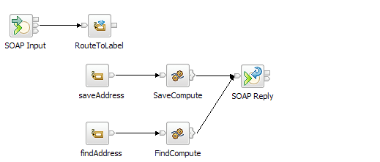

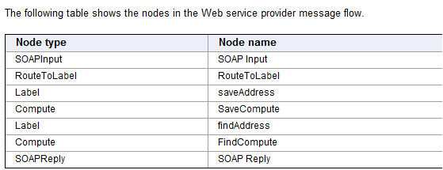

The flow is constructed by using a SOAPInput and a SOAPReply node. To automatically enter all of the properties for the SOAPInput node, drag the WSDL file onto the SOAPInput node. (The WSDL file is located in the message set project only after you have used the "Start from WSDL and/or XSD files" wizard.)
The SOAPInput node receives incoming SOAP messages and, if the messages are valid, passes them down the message flow to the RouteToLabel node. The RouteToLabel node forwards the message to the Label node, the name of which is located in the local environment (OutputLocalEnvironment.Destination.RouterList.DestinationData[1].labelname). You do not have to set this path explicitly when you are working with incoming SOAP messages because the SOAPInput node automatically sets the path to the name of the operation being called. However, you must connect the SOAPInput node to a RouteToLabel node and create a Label node for each operation.
If the operation being called is saveAddress, the message is sent to the SaveCompute node, where the address is stored in a shared ESQL variable. Shared variables last for the scope of the message flow; if you redeploy the message flow you lose any saved addresses.
If the operation being called is findAddress, the message is sent to the FindCompute node, where the shared variable is queried for the address of the person whose name is supplied in the input message. If the address is found, the address is returned; if the address is not in the shared variable, a SOAP fault is constructed.

Consumer Flow
The following figure shows the Web service consumer message flow:
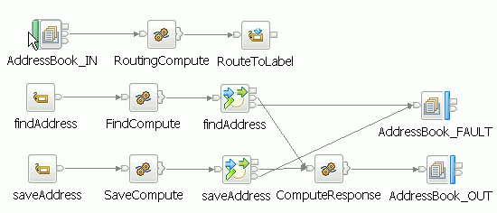
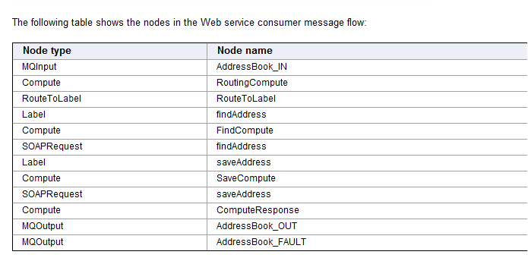

The Web service consumer flow is initiated by a WebSphere MQ message arriving on the queue monitored by the MQInput node. The message is an XML message in the XMLNSC domain. To use the RouteToLabel node, you must set the value in the local environment explicitly for this flow by using the RoutingCompute node:
OutputLocalEnvironment.Destination.RouterList.DestinationData[1].labelname = InputRoot.XMLNSC.request.operation
The message is then routed to the correct Label node. The Label node forwards the message to a Compute node that builds an outbound request message in the SOAP domain by using the input message. The message is forwarded to the correct SOAPRequest node, which calls the provider flow. The return message is sent to an MQOutput node, which writes the XML data to the specified WebSphere MQ queue.

The messages
The Web services consumer message flow is driven by a WebSphere MQ message. A Test Client file is supplied to run the sample by using the following XML message. The first message stores an address, the second message looks up that address. The first element specifies the operation to call; the remainder of the message is used to build the SOAP message that is sent to the provider flow

The messages
The Web services consumer message flow is driven by a WebSphere MQ message. A Test Client file is supplied to run the sample by using the following XML message. The first message stores an address, the second message looks up that address. The first element specifies the operation to call; the remainder of the message is used to build the SOAP message that is sent to the provider flow.
<request>
<operation>saveAddress</operation>
<Name>Dave</Name>
<City>Carlisle</City>
<Street>Welton</Street>
<Province>Cumbria</Province>
<PostalCode>NE2 3HP</PostalCode>
<Area>1</Area>
<Prefix>2</Prefix>
<Local>3</Local>
</request>
The second input message then looks up that address:
<request>
<operation>findAddress</operation>
<Name>Dave</Name>
</request>
SOAP messages are also provided to call the provider flow directly. These messages are equivalent to those that the consumer flow builds and sends from the two SOAPRequest nodes. The first SOAP message stores the address:
<?xml version="1.0" encoding="UTF-8"?>
<soapenv:Envelope xmlns:soapenv="http://schemas.xmlsoap.org/soap/envelope/"
xmlns:ns3="http://addressbook.com/" xmlns:xsi="http://www.w3.org/2001/XMLSchema-instance">
<soapenv:Body>
<ns3:Person>
<ns3:Name>Dave</ns3:Name>
<ns3:Address>
<ns3:City>Carlisle</ns3:City>
<ns3:Street>Welton</ns3:Street>
<ns3:Province>Cumbria</ns3:Province>
<ns3:PostalCode>NE2 3HP</ns3:PostalCode>
<ns3:PhoneNumber>
<ns3:Area>1</ns3:Area>
<ns3:Prefix>2</ns3:Prefix>
<ns3:Local>3</ns3:Local>
</ns3:PhoneNumber>
</ns3:Address>
</ns3:Person>
</soapenv:Body>
</soapenv:Envelope>
The second input message looks up the address:
<?xml version="1.0" encoding="UTF-8"?>
<soapenv:Envelope xmlns:soapenv="http://schemas.xmlsoap.org/soap/envelope/"
xmlns:tns="http://addressbook.com/" xmlns:xsi="http://www.w3.org/2001/XMLSchema-instance">
<soapenv:Body>
<tns:Name>Dave</tns:Name>
</soapenv:Body>
</soapenv:Envelope>

Client flow :

/*Sample program for use with IBM WebSphere Message Broker
© Copyright International Business Machines Corporation 2009, 2010
Licensed Materials - Property of IBM*/

DECLARE ns2 NAMESPACE 'http://addressbook.com/';

CREATE COMPUTE MODULE AddressBookConsumerFlow_FindCompute
CREATE FUNCTION Main() RETURNS BOOLEAN
BEGIN
/**
* Set the name to seach for from the input XML.
*/
SET OutputRoot.Properties.CodedCharSetId = 1208;
SET OutputRoot.SOAP.Body.ns2:Name = InputRoot.XMLNSC.request.Name;
RETURN TRUE;
END;
END MODULE;

CREATE COMPUTE MODULE AddressBookConsumerFlow_SaveCompute
CREATE FUNCTION Main() RETURNS BOOLEAN
BEGIN
/*
* Declare a reference to the request so it is only navigated to once.
*/
DECLARE request REFERENCE TO InputRoot.XMLNSC.request;
SET OutputRoot.Properties.CodedCharSetId = 1208;

SET OutputRoot.SOAP.Body.ns2:Person.ns2:Name = request.Name;
SET OutputRoot.SOAP.Body.ns2:Person.ns2:Address.ns2:City = request.City;
SET OutputRoot.SOAP.Body.ns2:Person.ns2:Address.ns2:Street = request.Street;
SET OutputRoot.SOAP.Body.ns2:Person.ns2:Address.ns2:Province = request.Province;
SET OutputRoot.SOAP.Body.ns2:Person.ns2:Address.ns2:PostalCode = request.PostalCode;
SET OutputRoot.SOAP.Body.ns2:Person.ns2:Address.ns2:PhoneNumber.ns2:Area = request.Area;
SET OutputRoot.SOAP.Body.ns2:Person.ns2:Address.ns2:PhoneNumber.ns2:Prefix = request.Prefix;
SET OutputRoot.SOAP.Body.ns2:Person.ns2:Address.ns2:PhoneNumber.ns2:Local = request.Local;
RETURN TRUE;
END;
END MODULE;

CREATE COMPUTE MODULE AddressBookConsumerFlow_Routing
CREATE FUNCTION Main() RETURNS BOOLEAN
BEGIN
/**
* Route to label based on the operation name specified.
*/
SET OutputRoot.XMLNSC = InputBody;
SET OutputLocalEnvironment.Destination.RouterList.DestinationData[1].labelname = InputRoot.XMLNSC.request.operation;
RETURN TRUE;
END;

END MODULE;

CREATE COMPUTE MODULE AddressBookConsumerFlow_ComputeResponse
CREATE FUNCTION Main() RETURNS BOOLEAN
BEGIN
SET OutputRoot.Properties = InputRoot.Properties;
SET OutputRoot.SOAP.Body = InputRoot.SOAP.Body;
RETURN TRUE;
END;
END MODULE;

Provider flow:

/*Sample program for use with IBM WebSphere Message Broker
© Copyright International Business Machines Corporation 2009, 2010
Licensed Materials - Property of IBM*/

DECLARE ns NAMESPACE 'http://addressbook.com/';
DECLARE soapenv NAMESPACE 'http://schemas.xmlsoap.org/soap/envelope/';
DECLARE Tree SHARED ROW;

CREATE COMPUTE MODULE AddressBookFlow_SaveCompute
CREATE FUNCTION Main() RETURNS BOOLEAN
BEGIN
/*
* Declare a reference to the SOAP body so we can easily access
* all of the elements.
*/
DECLARE body REFERENCE TO InputRoot.SOAP.Body;
/**
* Atomic section, accessing the shared variable.
*/
InsertPerson : BEGIN ATOMIC
DECLARE I INTEGER;
-- ESQL Lists are indexed from 1.
SET I = CARDINALITY(Tree.Persons[]) + 1;
-- Add the person at the end of the list.
SET Tree.Persons[I] = body;
END InsertPerson;
SET OutputRoot.SOAP.Body.ns:SaveAddressResponse = 'true';
RETURN TRUE;
END;
END MODULE;

CREATE COMPUTE MODULE AddressBookFlow_FindCompute
CREATE FUNCTION Main() RETURNS BOOLEAN
BEGIN
DECLARE address ROW;

/**
* Select all the People whose name match the input.
*/
SET address.addresses[] =
(
SELECT A.ns:Person.ns:Address
FROM Tree.Persons[] AS A
WHERE A.ns:Person.ns:Name = InputRoot.SOAP.Body.ns:Name
);
/*
* Check that there was at least one match and return the first.
* This does not return the entire list.
*/
IF EXISTS(address.addresses[]) THEN
SET OutputRoot.SOAP.Body = address.addresses[1];
ELSE
/**
* Otherwise set the status code to 500 and construct a SOAP Fault.
*/
SET OutputLocalEnvironment.Destination.SOAP.Reply.Transport.HTTP.ReplyStatusCode = 500;
/*
* Construct the SOAP fault.
*/
SET OutputRoot.SOAP.Body.soapenv:Fault.faultcode = 'NS1:Server';
SET OutputRoot.SOAP.Body.soapenv:Fault.faultstring = 'Server Error';
SET OutputRoot.SOAP.Body.soapenv:Fault.detail.ns:FindAddressFault.ns:Comment = 'Address does not exist';
END IF;

RETURN TRUE;
END;

END MODULE;

